Name:  Teacher: | ____________________________________  ________________ |  | Date:_________
 | Year 10 OLNA Mathematics  SCORE:  /46  Mini test  Topic – Linear Equations  Full working out MUST be shown to get full marks for each question.
Total Time: | 45 minutes
Weighting: | 10 %
Equipment: | To be provided by the student: Pens and Pencils, Ruler, Scientific calculator, INB.

- [ 7 marks] Vertical and horizontal distances
Consider the following graph
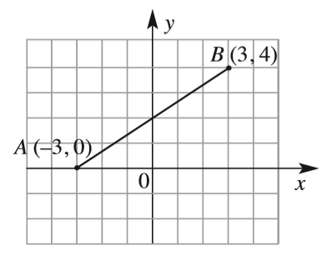 | - What is the rise between A and B?  - What is the run between A and B?  - What is the gradient of the line?  - Where does the line cross the y axis?  - What is the equation of the line?

- [16 marks]
Complete the following table of values
$$y=2x+3$$

X | 0 | 1 | 2 | 3 | 4 | 5 | 6
Y

$$y= -x+1$$

- [10 marks]
Label the following as linear or non-linear. For linear tables, what is the equation of the line?

x | 0 | 1 | 2 | 3 | 4 | 5 | 6
Y | 3 | 5 | 7 | 9 | 11 | 13 | 17

Linear: Yes / No Equation:

x | -3 | -2 | -1 | 0 | 1 | 2 | 3
Y | 8 | 9.25 | 10.5 | 11.75 | 12 | 12.25 | 13.5

Linear: Yes / No Equation:

x | -3 | -2 | -1 | 0 | 1 | 2 | 3
Y | 6 | 4.85 | 3.7 | 2.45 | 1.1 | -0.35 | -1.9

Linear: Yes / No Equation:

x | -3 | -1 | 2 | 4 | 5 | 6 | 8
Y | 12 | 10 | 7 | 5 | 4 | 3 | 1

Linear: Yes / No Equation:

- [9 marks]
Sketch the following graphs on the set of axes (Label your graphs)

- $y=x+2$ | - $y=-2x+3$ | - $y=-2x+10$
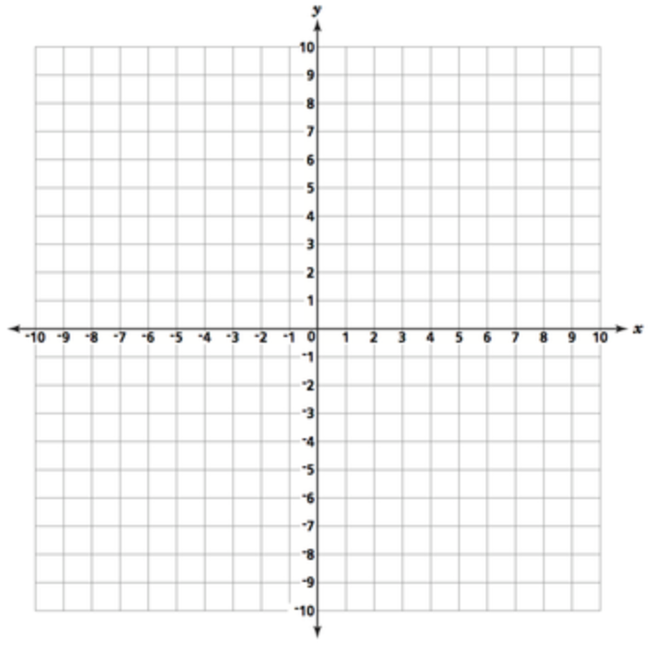

- [4 marks]
Match the equation to the graph
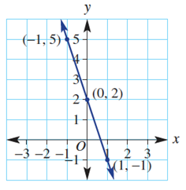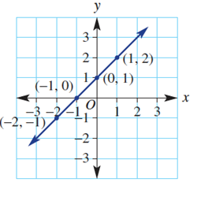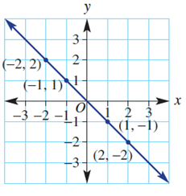 | - $x+y=0$  - $y=x+1$  - $y=-3x+2$

End of Test

